e-day lesson # 1

Chemistry Lesson # 1

Instruction

- Go to the following website: http://www.wfu.edu/~ylwong/balanceeq/balanceq.html

  - Follow through the tutorial on how to balance chemical equations
  - The tutorial will take you through counting atoms on the reactant and product side of a chemical equation. It will then teach you how to add coefficients to balance the equation.
  - Once you are finished with the tutorial, click on the “Exercises” link on the left side of the web page. You will see it under the Balancing equations tab, under the General Chemistry tab….see image below

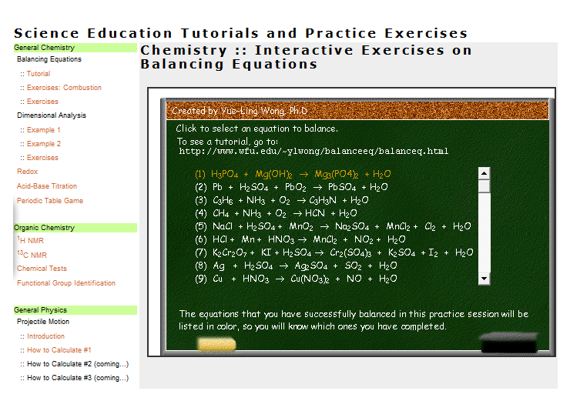
- Once you click on the exercise tab, 9 equations will pop up. You must balance all 9 of them. When you have done them correctly, the equation will turn yellow (see above picture)

Assessment

- Complete the balancing equations worksheet that is attached

