Biology e-day Lesson # 1

Instruction

- Go to the following website: https://theisland.studyisland.com/

  - Log onto your study island account (you should have your username and password)
  - Click on the black science tab on the top of the page
  - A bunch of science classes will pop up. Click on AP Biology (AP Biology Review)

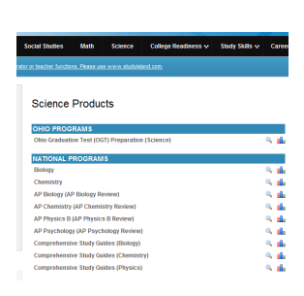
- A bunch of topics will pop up. Locate the Mendelian Genetics topic and read the lesson by clicking on the orange lesson button. Once you have read the lesson, click on Mendelian Genetics
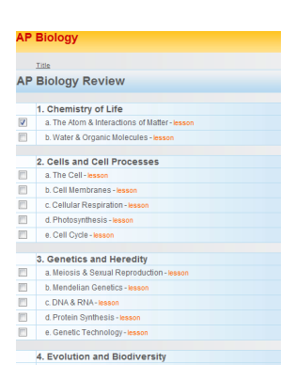
Assessment
- Click Test Mode, change the # of ?’s to 20 and answer the questions. I will be able to see your progress and % on the assignment.

