Biology e-day Lesson # 3

Instruction

- Go to the following website: http://ogt.success-ode-state-oh-us.info/studentsOGT.htm

  - Click on Practice For The Tests
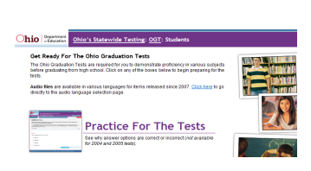
  - Click on take a test without logging in
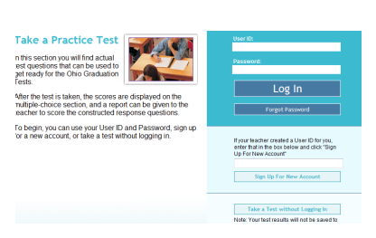
  - Click on Science (on the right hand side, click on 2009 test, click start test
  - Answer the questions hitting save and continue after each question
  - At the end submit the test

Assessment
I will check your progress and accuracy on this test and its questions

